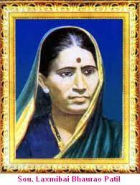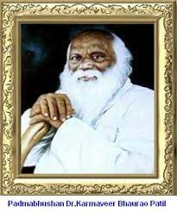

**Rayat Shikshan Sanstha’s**

**Laxmibai Bhaurao Patil Mahila Mahavidyalaya, Solapur**

**1428, ModiKhana, Saat Rasta, Solapur.**

**Affiliated to PunyashlokAhilyadeviHolkarSolapur University,Solapur**

**Reaccredited by NAAC with A Grade (CGPA 3.23)**

**An ISO 9001 : 2015 Certified College**

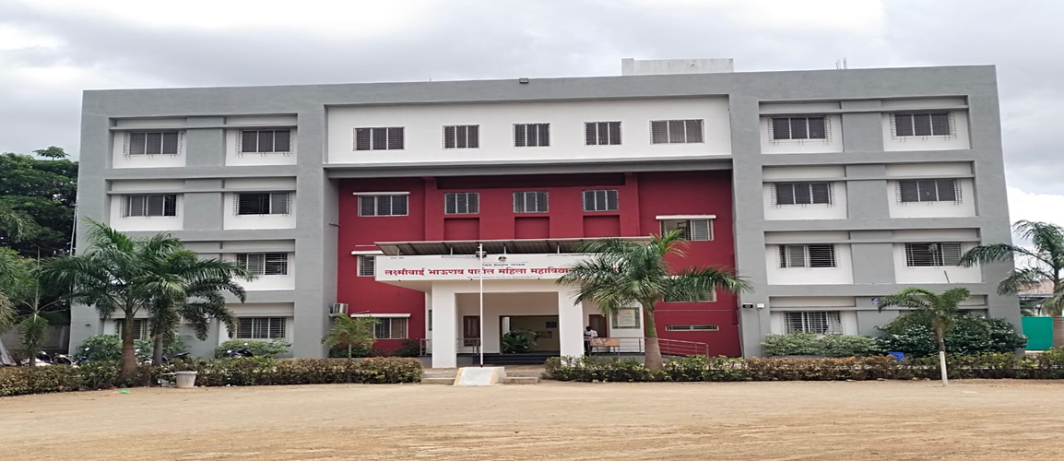

**Matrix 1.2.1Number of Certificate/Value added courses offered and online courses of MOOCs, SWAYAM, NPTEL etc. (where the students of the institution have enrolled and successfully completed during the last five years)**

**SELF STUDY REPORT FOR NAAC ACCREDITATION -CYCLE -4**

**SELF STUDY REPORT FOR NAAC ACCREDITATION -CYCLE -4**

**Matrix 1.2.1Number of Certificate/Value added courses offered and online courses of MOOCs, SWAYAM, NPTEL etc. (where the students of the institution have enrolled and successfully completed during the last five years)**

List of Supporting Documents

|  |  |  |
| --- | --- | --- |
| **Sr. No.** | **Particulars** | **Supporting Documents** |
| 1. | **Year- Wise List of Addon /Certificate/Value added Courses** | [**View Document**](https://www.lbpmsolapur.org/admin/file_photo/Year-wise%20list%20of%20Add%20on%20Certificate%20Value%20added%20Courses.pdf-b4xJ7.pdf) |

|  |  |  |
| --- | --- | --- |
| **Sr. No.** | **Particulars** | **Supporting Documents** |
|  | **List of Add on/ Certificate/ Value added Courses 2022-23** | [**View Document**](https://www.lbpmsolapur.org/admin/file_photo/ST%20202223.pdf-9gCbe.pdf) |
|  | **List of Enrolled Students and Attendance Sheet 2022-23** | [**View Document**](https://www.lbpmsolapur.org/admin/file_photo/List%20of%20Student%20&%20Attendance%20sheet%202022-23.pdf-IHdzD.pdf) |
|  | **List of Add on/ Certificate/ Value added Courses 2021-22** | [**View Document**](https://www.lbpmsolapur.org/admin/file_photo/ST%20202122.pdf-kJ8t6.pdf) |
|  | **List of Enrolled Students and Attendance Sheet 2021-22** | [**View Document**](https://www.lbpmsolapur.org/admin/file_photo/List%20of%20Student%20&%20Attendance%20sheet%202021-22.pdf-XQ2Dr.pdf) |
|  | **List of Add on/ Certificate/ Value added Courses 2020-21** | [**View Document**](http://www.lbpmsolapur.org/admin/file_photo/ST%20202021.pdf-TlsDu.pdf) |
|  | **List of Enrolled Students and Attendance Sheet 2020-21** | [**View Document**](https://www.lbpmsolapur.org/admin/file_photo/List%20of%20Student%20&%20Attendance%20sheet%202020-21.pdf-N9qbV.pdf) |
|  | **List of Add on/ Certificate/ Value added Courses 2019-20** | [**View Document**](https://www.lbpmsolapur.org/admin/file_photo/ST%20201920.pdf-v3JX8.pdf) |
|  | **List of Enrolled Students and Attendance Sheet 2019-20** | [**View Document**](https://www.lbpmsolapur.org/admin/file_photo/List%20of%20Student%20&%20Attendance%20sheet%202019-20.pdf-8m9oA.pdf) |
|  | **List of Add on/ Certificate/ Value added Courses 2018-19** | [**View Document**](https://www.lbpmsolapur.org/admin/file_photo/ST%20201819.pdf-oAQW4.pdf) |
|  | **List of Enrolled Students and Attendance Sheet 2018-19** | [**View Document**](https://www.lbpmsolapur.org/admin/file_photo/List%20of%20Student%20&%20Attendance%20sheet%202018-19.pdf-0NVWu.pdf) |

|  |  |  |
| --- | --- | --- |
| **Sr. No.** | **Particulars** | **Supporting Documents** |
| 1. | **Brochure/ Notice of Add On / Certificate Courses** | [**View Document**](http://www.lbpmsolapur.org/admin/file_photo/Brochure,%20Notice.pdf-mrQGX.pdf) |
| 2. | **Course Completion Certificates** | [**View Document**](https://www.lbpmsolapur.org/admin/file_photo/Certificate.pdf-K0nUD.pdf) |
| 3. | **Bos/Syllabus of Add on/ Certificate/ Value added Courses** | [**View Document**](https://www.lbpmsolapur.org/admin/file_photo/Bos,Syllabus.pdf-opdDi.pdf) |
| 4. | **One Page Report of Add on/ Certificate/ Value added Courses** | [**View Document**](https://www.lbpmsolapur.org/admin/file_photo/one%20Page%20report.pdf-vO14Q.pdf) |

**SELF STUDY REPORT FOR NAAC ACCREDITATION -CYCLE -4**